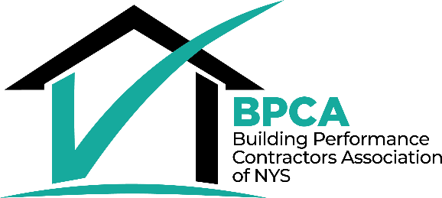

Residential Contracting Company

COVID-19 Operations Policy Template
Ver 1.0 July 2020
Table of Contents

Introduction 2
Policy Goals & Principles 2
PART 1: Preparation Checklist 2
Education, Communication, and Safety Plan Preparations 2
Preparations: Office, Vehicles, Work Site 4
PART 2: Policy Template 7
Before coming to work 7
At work (all locations) 8
At the office 9
Work Travel in Motor Vehicles 10
Deliveries 10
Onsite work (customer site): Planning 10
Onsite work (customer site): Pre-Arrival 11
Onsite work (customer site): Arrival 12
Onsite work (customer site): While working 13
Onsite work (customer site): Departing 15
PART 3: Example Materials 16
Sample Signage 16
Safe Glove Removal Process 20
Sample Customer Safety Commitment 21
Sample Health Screening Questionnaire 23
Sources 24

Introduction
This document represents the known best practices for safe work in a COVID environment as of the revision date. It is meant to supply contractors with a template that should be customized - then integrated - into each company’s operational procedures. Adapt this policy template for your business, then adopt the policy, incorporating it into your company’s procedures documentation. Provide copies and training to all employees and sub-contractors. Include it in new-hire training.

Policy Goals & Principles
- Maintain employee and client safety, health, and well-being.
- Enable essential operations while taking appropriate safety precautions.
- Support both office and field employees.
- This policy is applicable for all types of residential energy efficiency and heating and cooling work.
- This policy shall be updated on an as-needed basis using the latest guidance from federal and state officials.

PART 1: Preparation Checklist

Education, Communication, and Safety Plan Preparations
Complete these steps:
Completed |  | Item
Initials | Date
- Review existing company policies and documentation and make COVID-related updates. This includes:
  - Harassment: Reporting of complaints or harassment; handling of claims of harassment (employees may perceive harassment about health status)
  - Become familiar with New York State’s Paid Leave Benefits for COVID-19 at https://paidfamilyleave.ny.gov/COVID19. Incorporate applicable changes into this policy or existing time off policies.
  - Provide training and documentation to designated OSHA reporting staff. OSHA has made a determination that confirmed COVID-19 cases at work meet the criteria for recordability and reportability under OSHA’s recordkeeping rule. OSHA requires employers to conduct an assessment of any workplace exposures to determine if the case is work-related. Work-relatedness is presumed for illnesses that result from events or exposures in the work environment, unless it meets certain exceptions. One of those exceptions is that the illness involves signs or symptoms that surface at work but result solely from a non-work-related event or exposure that occurs outside of the work environment. Thus, if a team member develops COVID-19 solely from an exposure outside of the work environment, it would not be work-related, and thus not recordable. More information can be found here.
  - Consider policy changes to allow and/or encourage employees with enhanced risk factors (especially those affecting the immune system) to work from home where possible.
- Stay up-to-date
  - NYS and NYSERDA guidance at https://www.nyserda.ny.gov/ny/COVID-19-Response/Contractor-and-Construction-Guidance
  - Sign up to receive the latest COVID news and announcements from NYSERDA at https://www.nyserda.ny.gov/ny/COVID-19-Response/Stay-Updated-on-COVID-19
  - Monitor the CDC website for updates at https://www.cdc.gov/coronavirus/2019-ncov/index.html
  - All construction activities must follow the New York State Department of Health Interim Guidance for Construction Activities. Guidance as of June 26, 2020 is incorporated into this template.
 |  | - A NY Forward Safety Plan addressing the requirements must be developed and communicated to staff. The New York State Department of Health (DOH) has provided a template here.
 |  | - Post the completed safety plan conspicuously at all company work locations including all company vehicles.
 |  | - At least one authorized representative from every company must, as a prerequisite to undertaking any field or return to office work, attest that they have reviewed the DOH construction guidance and shared its contents with all company staff. The attestation form is located here.
 |  | - Provide COVID-safe work practice training to employees. A NYSERDA worker training video is available here. To the extent possible, conduct training remotely through an online meeting tool for employees capable of connecting. In addition to reviewing all of the information in this Policy, include reminders about your company’s anti-harassment and complaint policies. Include disinfection instructions for products used by your company and incorporate MSDS sheets into the Policy. If applicable, provide training in other languages if those are the only ones understood by employees.
 |  | - Modify processes to allow for electronic document transfer and e-signatures as much as possible.
- Develop a Customer Safety Commitment document to share with customers. Topics to include:
  - Company commitment to safety and well-being of customers and employees
  - Employee self-evaluation and health screening that take place at the start of each workday
  - Precautions taken in the home (distancing, protective coverings, etc)
  - Clean-up that will take place at end of workday and end of job
  - List of questions that crew leader will ask when they arrive onsite
  - Contact information in case customer has questions
A sample template appears in part 3 of this document.
- Acceptable face coverings must be procured and provided to employees while at work, at no cost to the employee. Signage indicating proper usage (covering nose and mouth) must be provided.
  - Acceptable face coverings for COVID-19 include but are not limited to cloth-based face coverings and disposable masks that cover both the mouth and nose.
    - Cloth, disposable, or other homemade face coverings are not acceptable face coverings for workplace activities that typically require a higher degree of protection from personal protective equipment due to the nature of the work. For those activities, masks shall be selected according to OSHA guidelines, industry standards and manufacturer specifications.

Preparations: Office, Vehicles, Work Site
Complete these steps in each office or work location:
Completed |  | Item
Initials | Date
- Limit face to face interaction to the extent possible
  - Limit in person presence to necessary staff
  - Adjust workplace hours when appropriate
  - Reduce on-site workforce to accommodate social distancing
  - Shift design including use of A/B teams and staggered arrival and departure times
  - In person gatherings, including jobsite meetings, must be limited to the extent possible in favor of other methods such as video or teleconference
- Adjust workspaces. The number of work stations and employee seating areas, and their use, may be modified or restricted, so that workers are at least six feet apart in all directions (e.g. side-to-side and when facing one another) and are not sharing workstations without cleaning and disinfection between use. When distancing is not feasible, the use of face coverings or physical barriers (e.g. plastic shielding walls, in lieu of face coverings in areas where they would not affect air flow, heating, cooling, or ventilation) must be provided and required.
  - Physical barriers should be put in place. Options may include: strip curtains, plexiglass or similar materials, or other impermeable dividers or partitions.
 |  | - Restroom access, where feasible, should be reduced to allow social distancing.
- Signs consistent with DOH COVID-19 signage must be posted throughout the workplace. Customized signage specific to a workplace or setting can be developed and used, provided that such signage is consistent with the Department’s signage. See Sample Signage. Signage must be installed to remind employees to:
  - Cover their nose and mouth with a mask when social distancing cannot be maintained
  - Adhere to social distancing instructions. Post signage and distance markers denoting spaces of six feet in all commonly used areas and any areas in which lines are commonly formed or people may congregate (e.g. clock in/out stations, health screening stations, etc.).
  - Report symptoms of COVID-19 exposure and how to do so
  - Follow handwashing and cleaning guidelines
  - Reduce bi-directional foot traffic using tape or signs with arrows in narrow aisles, hallways, or spaces.
  - Reduce the use of tightly confined spaces, such as elevators and vehicles. Occupancy by more than one person at a time is prohibited unless all employees are wearing acceptable face coverings. Occupancy of confined spaces may never exceed 50% of the maximum capacity.
  - Properly store and, when necessary, discard personal protective equipment.
See Sample Signage
- Hand hygiene stations must be provided and maintained at every site (office and remote).
  - For handwashing: soap, running water, and disposable paper towels.
  - For sanitizer: an alcohol-based hand sanitizer containing at least 60% alcohol for areas where handwashing facilities may not be available or practical.
 |  | - Masks, nitrile gloves, and hand sanitizer will be available at the reception desk and all entrances for office personnel, visitors, and contractors
- Routine cleaning should be rigorous and ongoing, and time should be allocated for individuals to routinely clean work spaces. Cleaning should include high contact surfaces that are touched by many different people, such as light switches, handrails, doorknobs/handles, and kitchen/breakroom surfaces like vending machine pads, microwave oven keypads, and refrigerator handles. Regular cleaning and disinfecting of restrooms must be ensured. Restrooms should be cleaned more often depending on frequency of use.
  - Materials such as wipes, cleaners and disinfectants shall be provided along with education on their use. Materials and signage should be placed near equipment such as printers, copiers, refrigerators, and coffee makers so each person cleans it after use. A list of disinfectants is available here. Recommended cleaning practices are available here.
  - PPE such as nitrile, latex, or vinyl gloves should be provided for workers performing cleaning and trash removal.
  - If an employee goes home sick, their work area and other areas they occupied during the workday should be vacated by all staff until they are cleaned per section 3 under “At The Office”.
- Prepare Company vehicles
  - Stock disinfectant spray, wipes, hand sanitizer and disposable trash bags in the vehicles.
    - Provide signage to promote hand hygiene and cleaning of frequently touched surfaces.
 |  | - Shared food and beverages (e.g. buffet style meals) must be prohibited, bringing lunch from home should be encouraged, and adequate space for employees to observe social distancing while eating meals must be identified and reserved.
 |  | - Individuals tasked with receiving shall put on nitrile gloves before handling any inbound materials. Any parts, materials, or packages shall be sprayed with disinfectant and allowed to dry prior to further handling.
- Implement daily health and temperature screenings. Health screenings can take place at home by the employee and/or onsite. Those taking place onsite should be outside or in an isolated location immediately within the building. Staff may not proceed further into the building before being screened.
  - At a minimum, screening should be required of all workers and visitors and completed using a questionnaire that determines whether the worker or visitor has:
    - Knowingly been in close or proximate contact in the past 14 days with anyone who has tested positive for COVID-19 or who has or had symptoms of COVID-19
    - Tested positive for COVID-19 in the past 14 days,
    - Has experienced any symptoms of COVID-19 in the past 14 days: Fever or chills, Cough, Shortness of breath or difficulty breathing, Fatigue, Muscle or body aches, Headache, New loss of taste or smell, Sore throat, Congestion or runny nose, Nausea or vomiting, Diarrhea
  - If using on-site screenings, temperature should be taken by a trained person wearing facial covering using a no-touch thermometer.
  - Process & Confidentiality
      - Screening should be coordinated so employees maintain 6-foot social distancing
      - Readings should be taken in a private location
      - Results should be delivered discretely
      - Keeping records of employee health data is prohibited.
  - If employees are self-screening at home, instructions should be provided for taking your own temperature:
    - Read the instructions that came with your thermometer
    - Wash your hands with soap and warm water before using the thermometer
    - Clean the thermometer before and after each use per instructions
    - If you have been eating or drinking, wait 30 minutes before you take a temperature by mouth
    - If you have been exercising or out in the hot/cold,
wait before taking your temperature
  - An employee who screens positive for COVID-19 symptoms or has close contact with known cases should not be allowed to enter the worksite, and should be sent home with instructions to contact their healthcare provider for assessment and testing. The local health department and DOH must be immediately notified about the suspected case. Information about local testing can be found here: https://health.ny.gov/contact/contact_information/
  - All employee and visitor responses collected by the screening process on a daily basis must be reviewed and a record of such review (but not a record of the medical data) must be maintained (actual responses and results like temperature readings should not be retained and should be securely disposed of if documented in writing). An emergency contact must be identified.
  - To the extent possible, a log of every person, including workers and visitors, who may have close contact with other individuals at the work site or area must be maintained; excluding deliveries that are performed with appropriate PPE or through contactless means. The log should contain contact information, such that all contacts may be identified, traced and notified in the event an employee is diagnosed with COVID-19. Cooperation with local health departments contact tracing efforts is required.
- Provide acceptable face coverings to employees at no cost to the employee
  - Must allow employee-provided face coverings if acceptable
- Employers must provide accommodations to employees who are not able to medically tolerate face coverings
  - Examples of accommodations include alternative PPE, isolated work locations, or new work assignments

PART 2: Policy Template

Before coming to work

General Fit-for-Work Requirements
  - If you are sick or feeling ill in any way, including with COVID-19 symptoms, you are considered sick and shall stay home and not come to work. COVID-19 virus symptoms include: Fever or chills, Cough, Shortness of breath or difficulty breathing, Fatigue, Muscle or body aches, Headache, New loss of taste or smell, Sore throat, Congestion or runny nose, Nausea or vomiting, Diarrhea. Employees should notify their supervisor and stay home if they are sick. Refer to CDC guideline: What To Do if You Are Sick.
  - Any person who has had close contact with a confirmed COVID-19 patient will not be allowed to enter the office or job site for 14 days starting from the day they last interacted with the person with COVID-19. “Close contact” is defined as being within 6 ft of a person with a confirmed case of COVID-19 for a prolonged period of time.
  - Persons with COVID-19 symptoms, confirmed or suspected COVID-19, or who were directed to care for themselves at home may return to work under the following conditions:
    - At least 3 days (72 hours) have passed since recovery defined as resolution of fever without the use of fever-reducing medications; and
    - Improvement in respiratory symptoms (e.g., cough, shortness of breath); and,
    - At least 10 days have passed since symptoms first appeared.

Sick Family Member(s)

Stay home if you are taking care of a sick family member. If the family member has COVID-19, see section 1.2 above.

At work (all locations)
- To reduce the density of people in a space at a given time, if your work is not time-dependent and can be completed successfully, ask your supervisor about a flexible shift option.
- Mandatory daily health screenings will take place. Report symptoms or possible exposure accurately.
  - Except for circumstances in which the Company is legally required to report workplace occurrences of communicable disease, the confidentiality of all medical conditions will be maintained in accordance with applicable law and to the extent practical under the circumstances. When it is required, the number of persons who will be informed that an unnamed employee has tested positive will be kept to the minimum needed to comply with reporting requirements and to limit the potential for transmission to others. The Company reserves the right to inform other employees that an unnamed co-worker has been diagnosed with COVID-19 if the other employees might have been exposed to the disease so the employees may take measures to protect their own health. The Company also reserves the right to inform sub-contractors, vendors/suppliers or visitors that an unnamed employee has been diagnosed with COVID-19 if they might have been exposed to the disease so those individuals may take measures to protect their own health.
- Employees who appear to have acute respiratory illness symptoms (i.e. cough, shortness of breath) upon arrival to work, or become sick during the day, should be separated from other employees and be sent home immediately. Contact your supervisor and Human Resources as soon as possible.
- If you find yourself sick at work and you’re not wearing a mask and gloves, don them immediately. Collect your personal possessions (keys, phone, etc) and leave the building or work site immediately. Contact your supervisor and Human Resources as soon as possible.
- Practice social distancing by maintaining six (6) feet of distance from all other persons. When social distancing cannot be maintained, facial coverings shall be worn. Employees must be prepared to wear a face covering if another person unexpectedly comes within six feet.
- Follow CDC guidance regarding coughing, sneezing and hand washing
  - Follow the below steps even if you are wearing a facial covering.
    - Cover your mouth and nose with a tissue when you cough or sneeze.
    - Put your used tissue in a waste basket. If you do not have a tissue, cough or sneeze into your upper sleeve, not your hands.
    - Wash your hands after coughing or sneezing: Improved hand hygiene is one of the most important steps to take to avoid getting sick and spreading the virus to others.
- Avoid unnecessary touching of your face and eyes. A facial covering will help limit this.
- Wash your hands often with soap and water for at least 20 seconds, especially after using the restroom; before eating; and after blowing your nose, coughing, or sneezing.
- Avoid unnecessary touching of others, including shaking hands. Instead, use a kind verbal greeting or head nod.
- Avoid unnecessary touching of another employee’s workstation, tools, vehicle, etc. If you use a company workstation, tool or vehicle that is used by others, wipe it down when you are done.
- Keep the office and your work environment clean.
- Masks and gloves are not to be shared among co-workers.
- Refer to the Department of Environmental Conservation (DEC) list of products registered in New York State and identified by the EPA as effective against COVID-19.
- Become familiar with the company Safety Plan.

At the office
- Personal protective equipment (PPE)
  - Facial covering (per CDC guidance) must be worn in the following scenarios
    - When social distancing cannot be maintained
    - Whenever inside a client's home/building regardless of social distancing
    - Exceptions made only on a case-by-case basis following discussion with your supervisor
    - Facial covering shall be washed, sanitized or replaced daily or more often as needed
  - Hand sanitizer (or equivalent) will be made available and shall be utilized at all transitions between activities and tasks.
  - See additional glove requirements for field operations
- Protocol for inviting external stakeholders into the office
(interviewees, contractors, vendors, customers, etc.)
  - Pre-arrival procedure
    - Personnel shall be sent this policy and expected to follow all protocols.
    - When scheduling the visit, a conversation will occur to ensure they received and understand these policies
    - Conduct health screenings identical to the screening used for arriving employees.
  - Job applicants
    - An employer may take an applicant's temperature as part of a post-offer, pre-employment medical examination.
    - An employer may screen applicants for symptoms of COVID-19 after making a conditional job offer.
    - An employer may delay the start date of an applicant who has COVID-19 or symptoms associated with it.
- If someone is suspected or confirmed to have COVID-19 infection on the work site, follow the CDC guidelines for “Cleaning and Disinfecting Your Facility”, including:
  - Close off areas used by the person who is sick, open doors and windows to outside, and wait 24 hours before cleaning and disinfecting
  - Clean and disinfect all areas used by the sick person
  - Once the area has been disinfected, it can be opened for use
- If more than 7 days have passed since the person who is sick was on site, additional cleaning and disinfection beyond routine procedures is not necessary.

Work Travel in Motor Vehicles
- In company vehicles, all frequently used surfaces (door handles, seats, steering wheel, keys, etc.) must be cleaned daily at minimum.
- Limit occupancy to one employee per vehicle when practical. Utilize additional vehicles to travel.
- If one person per vehicle is not possible, limit occupancy to no more than 50% of the normal capacity of the vehicle
- Avoid using the recirculated air option for the car’s ventilation; use the car’s vents to bring in fresh outside air and/or lower the vehicle windows
- Employees traveling in the same vehicle must wear face coverings at all times while in the vehicle.
- Limit stops – each introduces a point of exposure.
  - If any stops are required, wear PPE (face mask and disposable gloves). Remove and discard or disinfect PPE prior to re-entry of the production vehicle.
  - Use pay at the pump when possible
- Practice good hygiene – use hand sanitizer when re-entering the vehicle.

Deliveries
- When possible, have deliveries placed outside of the site or building then moved inside by employees.
- When possible, employees unloading deliveries allow drivers to remain socially distant by remaining in the cab.
- Provide signatures / delivery acknowledgements electronically.
- Personnel ordering equipment shall ensure the delivery driver understands that PPE is mandatory once they leave the vehicle. Drivers shall not exit delivery vehicles unless they are wearing a facial covering and gloves. If they must exit the vehicle but do not have a facial covering and gloves, this PPE shall be provided.

Onsite work (customer site): Planning
- Scheduling
  - Make contact:
    - Following basic welcomes, read the following information:
      - Hello [client name]. We are eager and excited to perform upcoming scheduled work or site visit. However, of course, we are very aware of the current environment. Please know that we have been continuously monitoring the situation and are following the guidance of public health, federal and New York State authorities. We are taking all mandated and recommended precautions and are following a strict protocol to keep you, our crew and the public safe. We want to make sure you are comfortable with our visit to your location. If you are uncomfortable with this visit, we will happily reschedule for a time when you are more comfortable with the situation. Should you have any concerns whatsoever, we would be happy to provide any information, including the opportunity to speak directly with one of our managers. Thank you for your help as I ask the following questions in order to schedule our visit.
    - Next ask: Is anyone in the home sick? Has anyone been tested and confirmed to have COVID-19 and is currently isolated in the home? Is anyone in the home self-quarantined or under quarantine by a local health department because of COVID-19? Has anyone in the home had contact with someone known to have COVID-19 in the past 14 days?
      - If no to all, then proceed as normal and schedule the site visit.
        - Request that the occupant sanitize the worksite prior to arrival.
        - Ask if there is a building manager or superintendant. If so, document for on-site crew.
      - If yes, I sincerely apologize for the inconvenience, but our policy is that I postpone the site visit until sick individuals are fully recovered. That is at least 3 days have passed since recovery defined as resolution of fever without the use of fever-reducing medications and improvement in respiratory symptoms (e.g., cough, shortness of breath) and at least 10 days have passed since symptoms first appeared.
  - For site visits that are scheduled:
    - If there is a building manager or super, make contact to review work scope, appointment details, gather information about potential common spaces that will be crossed to gain access to customer’s unit, what safety plans they have in place for the building, and get the building owner’s approval for the proposed work.
    - Provide any prior history or guidance to the staff who will be performing the site visit.
    - If applicable, provide building manager or super contact information to the crew
    - Develop a work plan for each site to ensure that crews are able to maintain social distancing.
    - Send client a copy of the Customer Safety Commitment.
    - Send client links to any e-signature documents (internal or NYSERDA program) that can be signed electronically.

Onsite work (customer site): Pre-Arrival
- Refer to the “General Fit-for-Work Requirements” above under ‘Before coming to work.’
- Conduct Daily Health Screenings, above under ‘At Work (All Locations).’
- Supplies should be stocked and drawn as needed
  - PPE
    - Facial coverings: Requirements as above. If working with dust, insulation, other building materials, masks shall be selected according to OSHA guidelines, industry standards and manufacturer specifications. Use should begin with conducting a user seal check.
    - Gloves
      - Gloves shall always be worn unless they impact the risk of using a tool properly
      - Plastic gloves shall be replaced at least daily
      - Leather or other work gloves shall be washed or disinfected at least daily
    - Face shields
    - Foot coverings/booties
  - Drop cloths
  - Disinfection wipes
  - Disinfection spray
  - Roll of paper towels (for handwashing)
  - Waste bags / tape / labels / markers
  - Hand Sanitizer: Requirements are the same as cited in the General Requirements
  - If using a handwashing station, jug of water and soap
  - Pre-addressed stamped envelopes for customers to mail paperwork/payments to the office
  - Printed copies of the Customer Safety Commitment
  - Pre-assemble materials and equipment required for a specific job
    - Stagger crew access to the production facility to prevent unnecessary overlap and allow for proper physical distancing.
    - Bin or plastic wrap materials per project, as possible.
    - Separate projects materials and equipment from other projects within the production facility.
    - Disinfect all equipment or materials prior to loading into production vehicle
- Daily pre-work conversations are required to review the plan and ensure all protocols are followed.
- Prior to the crew leaving, call the homeowner to:
  - Confirm nothing has changed since the appointment was set.
  - Affirm the crew is healthy and prepared to work safely.
  - Designate a single Point of Contact for both the customer and the work crew for on-site communication.
  - Confirm that the customer has made any preparations needed for the crew, e.g. informing everyone in the residence, clearing their personal belongings out of the area the crew will be working, around attic access doors, etc.
  - Ask the homeowner to designate a hand washing sink for the crew before they arrive. If one won’t be available, prepare the crew.

Onsite work (customer site): Arrival

- Put on PPE prior to leaving the production vehicle.
  - For how to properly don (put on) PPE, see CDC’s Demonstration of Donning PPE Video from 01:36-03:08 (respirator or mask) and 03:22-03:55 (gloves)
  - For how to properly doff (take off) PPE, see CDC’s Demonstration of Doffing PPE Video from 00:36-01:25 (gloves) and 02:27-3:06 (respirator or mask)
- Keep the cab section of the production vehicle as “clean” as possible, both physically as well as making sure to not enter or use the cab once PPE is donned and on-site work has started.
- If building has a building manager or super, check in with them first. Review their building safety plan, signage, common space crossings, and any other requirements.
- Customer greeting and screening
  - Upon arrival at the site and initial communication with the client, do not shake hands. Instead provide a kind head nod or bow. To the extent possible, limit in person conversation between the two individuals identified as points of contact for the customer and the work crew.
  - Following basic welcomes, and before entering the home, share the following sample statement: Hello [client name]. Please know that my crew (if applicable) and I are following official Contractor procedures to prevent the spread of COVID-19. Thank you for your help as I ask the following questions.
  - Next ask: Is anyone in the home sick? Has anyone been tested and confirmed to have COVID-19 and is currently isolated in the home? Is anyone in the home self-quarantined or under quarantine by a local health department because of COVID-19? Has anyone in the home had contact with someone known to have COVID-19 in the past 14 days?
    - If yes, decline to start work: Unfortunately, due to the risk involved in entering your home I will have to respectfully decline to start work at this time. Please know that I, or someone from the office will be following up shortly to reschedule the visit. I sincerely apologize for the inconvenience and look forward to following up soon.
    - If “No” to all questions, proceed with the next question.
  - Next ask: Per company policy, and as discussed when we scheduled this appointment, please provide verbal agreement to the following requests: Please confirm that you will be absent and not enter the room where we will perform work. (Pause and wait for response.) Please confirm that you will exercise “social distancing” practices at all times, including maintaining a minimum of six (6) feet from our workers at all times. (Pause and wait for response.) We’d also ask that you wear a mask when in-sight of our crew.
  - If they agree to all of the above requests, proceed with step 5.
    - If they do not agree or express concern about these requests or you encounter someone who is sick or exhibiting undesirable characteristics, please make the following statement: Unfortunately, due to the risk involved in entering your home I will have to respectfully decline to start work at this time. Please know that I, or someone from the office will be following up shortly to reschedule the visit. I sincerely apologize for the inconvenience and look forward to following up again soon.
  - In the event you cut a visit short or need to defer your work duties, inform your supervisor immediately.
- Set up "sandwich board" or placard signage for outdoor worksites describing the work, how it is compliant with COVID-19 guidelines, directing the public to keep safe distances, and offering contact information for questions/more info/to report unsafe practices.
- In occupied commercial or multi-family buildings, isolate work areas and entry/exit paths from occupants using signage, safety cones, caution tape, or other methods.
- Stage anticipated equipment to be used on-site by pulling it from the production vehicle prior to entering the site. When possible, keep the staging area outside, in the garage, or on the porch or deck. Keep clear separation between equipment and materials that have entered the site and those that have not been exposed to the site (“non-site”). Items handled or that come into contact with “site” exposed equipment or materials are to be considered “Site” equipment and treated accordingly. Site equipment and material require a greater attention to disinfection prior to returning to the production truck or being classified as “non-site”.
- Disinfect any equipment to be brought inside and set aside, outside the vehicle.
- Use separate shoe coverings for inside, that are not brought outside.
- If any paperwork requires customer signature and they are unable or unwilling to complete it electronically, leave it on a table or counter along with a postage-paid pre-addressed envelope. Ask the customer to sign it with their own pen after you leave and mail it back to the office.
- Document pre-work condition of work zones with comprehensive, clear photos.
- Document names of crew members working onsite and occupants present each day to help with contact tracing should it become necessary.

Onsite work (customer site): While working
- Social distancing
  - Pre-start “huddle” protocol limited to one representative from each subcontractor (ex. foreman) to discuss daily safety plans, work activities, deliveries, etc. This will be done at a safe distance outside or virtually.
  - Lunch gatherings shall maintain a safe worker distance of 6 feet or more. Site supervisors will organize a phased lunch schedule if needed. Crew will be encouraged to wash hands or use hand sanitizer if a sink or hand washing station isn’t available.
  - Maintain social distancing from homeowners, tenants, building staff. In a multi-family building, this may involve more trips with fewer people on stairs (preferred), elevators, and other common spaces.
  - Avoid touching frequently touched surfaces without gloves (such as handrails, elevator buttons etc.)
  - Close interior doors between work area(s) and areas occupied by residents.
- Ventilate
  - Open windows and doors to increase fresh air as much as possible.
  - In general, disabling of heating, ventilating, and air-conditioning systems is not recommended
  - Ventilation and filtration provided by HVAC systems can reduce the risk of transmission
  - Exhaust fans in bathrooms should be operated continuously, if possible
  - Do not use personal cooling fans and avoid having fans blow directly from occupants to workers (and vice versa) or from one worker to another
  - Air cleaners: Stand-alone air cleaners/air purifiers with particle filters should be operated continuously, if available. Air filter with high-efficiency media filter (e.g., MERV14 or higher) and have a high clean air delivery rate (CADR) are preferred
- Do not conduct blower door and duct blaster tests in occupied homes or apartments
until risk of COVID-19 transmission is reduced or safety procedures become available
- Use a work plan to minimize mixing inside and outside air and objects. People, equipment, and materials moving from inside the house to outside or vice-versa increase the chances of contamination.
    - Separation of tasks - installers that “stay” outside the site and supply equipment and materials to inside installers,
    - Separate outside and inside PPE, such as shoe coverings and gloves,

    - Block off any areas that will not require active work so as to reduce risk of contaminate spread and to define physical distancing areas
  - HVAC air filter changes (where required)
    - Assume filters have active microbial materials on them; the risks associated with handling filters contaminated with coronaviruses in ventilation systems under field-use conditions have not been evaluated
    - Change filters with system turned off
    - Wear disposable gloves, eye protection, and respiratory protection
    - Dispose of in sealed bag
    - When feasible, filters can be disinfected with a 10% bleach solution or appropriate disinfectant, before removal. Filters (disinfected or not) can be bagged and disposed of in regular trash
    - When maintenance tasks are completed, maintenance personnel should immediately
wash their hands with soap and water or use an alcohol-based hand sanitizer
- Document work progress with comprehensive, clear photos
- Report all health and safety concerns to your supervisor.

Onsite work (customer site): Departing
- Document work completed with comprehensive, clear photos
- Payment will be accepted via <Insert company payment options here>, mail, call-in credit card payment.
- Remove materials and equipment from the furthest work site backwards to the entrance/exit. Do not shake or unnecessarily disturb drop cloths or protection within the site.
- Discarded PPE must be put in red or “trash” labeled plastic bags, tied off, holes taped, and the exterior of the bag cleaned prior to loading into the vehicle for proper disposal.
- Reusable clothing (coveralls, hats, etc) must be placed in plastic bags labeled “dirty” tied off, holes taped, and the exterior of the bag cleaned prior to loading into the vehicle for proper cleaning.
- Equipment, tools, and materials must be regularly disinfected using registered disinfectants, including
  - As workers change workstations,
  - As workers move to a new set of tools,
  - At the end of each workday,
  - Whenever they are moved back to the truck
- Employees must ensure that the home is clean after the work is done. This includes routine cleaning and disinfecting of frequently touched surfaces (handrails, door knobs, keypads, etc.), equipment, and other elements of the work environment, using CDC approved disinfectants. If work took place in a multi-family building with common spaces, those must be disinfected as well (elevators, hallways, stairs).
- Prior to loading any materials or equipment into the production vehicle, put on new, clean gloves, clean in vehicle surfaces and equipment that might have been touched or come into contact with other possibly contaminated items during the workday.
- Use wipes to disinfect any parts of the vehicle that were touched after entering the site and use hand sanitizer after cleaning the equipment and vehicle, prior to driving.
- Employees must clean on-truck surfaces, knobs, switches, hoses, etc. on the production vehicle at the end of each workday.
- Clean all vehicle exterior handles, locks, keys, and personal items such as cell phones, tablets, binders, clipboards, etc.
- Do not return any material or equipment to the production building without cleaning/disinfecting it. A staging zone should be created at the production building to keep returning items separate until they can be cleaned before moving back into general stock.
- <Insert your company trash disposal practices/locations here>
- <If applicable Insert your company dirty laundry process here>
- Change work clothes prior to arriving home or as soon as practical
  - If work clothes must be worn home, establish a specific area to remove work clothing before entering the rest of the home (such as a garage or mudroom), and immediately put into wash.

PART 3: Example Materials

Sample Signage

Handwashing and Hand Sanitizer Use by CDC:
https://www.cdc.gov/handwashing/pdf/hand-sanitizer-factsheet.pdf

Free sign downloads to print from the Business Council of New York State.
https://www.bcnys.org/sites/default/files/2020-06/BCNYS_Social_Distancing_Signage_8.5x11.pdf

Free sign downloads to print from the CDC:
https://www.cdc.gov/coronavirus/2019-ncov/communication/print-resources.html?Sort=Date%3A%3Adesc

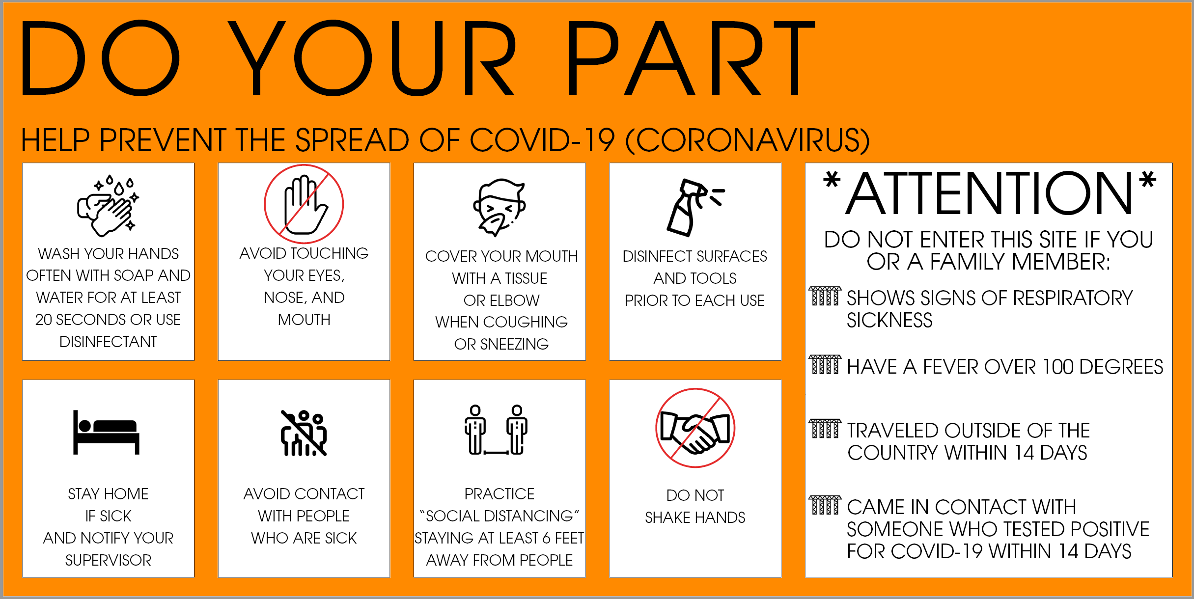

At entrances and screening locations:
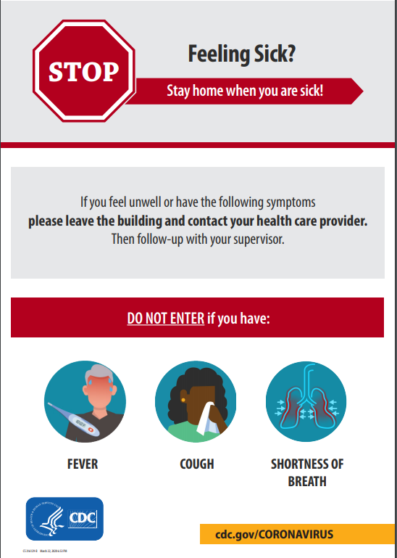
Available from: https://www.cdc.gov/coronavirus/2019-ncov/downloads/316129-B-StayHomeFromWork_Poster.pdf
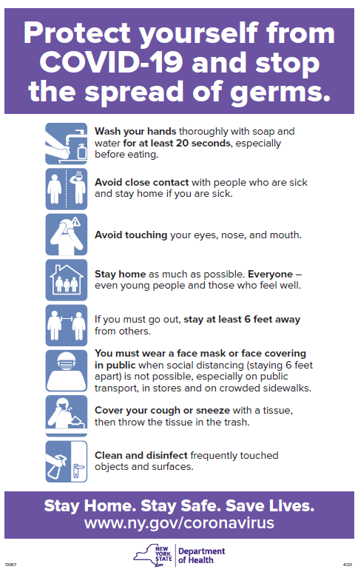
Available from: https://coronavirus.health.ny.gov/system/files/documents/2020/04/13067_coronavirus_protectyourself_poster_042020.pdf

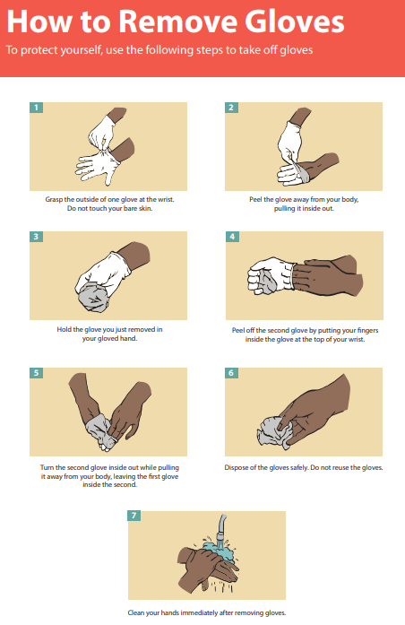
Available from https://www.cdc.gov/vhf/ebola/pdf/poster-how-to-remove-gloves.pdf?fbclid=IwAR0i5PeHnaG7yjcO99Guf6jL2vgbUtsGJz2cna-3gR2NKLsYLzdUFOWnYcY

Safe Glove Removal Process
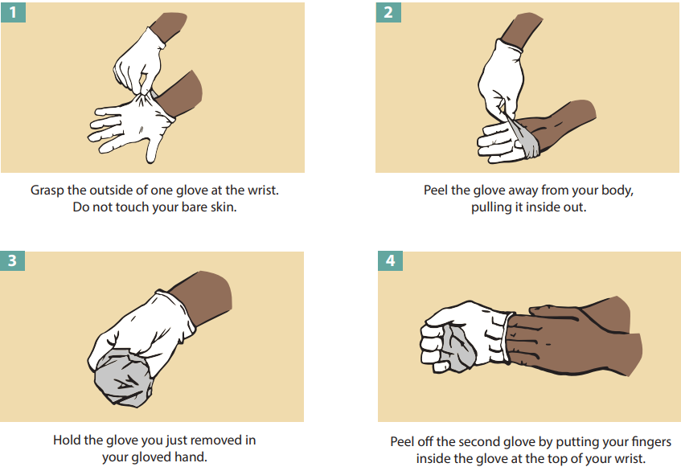
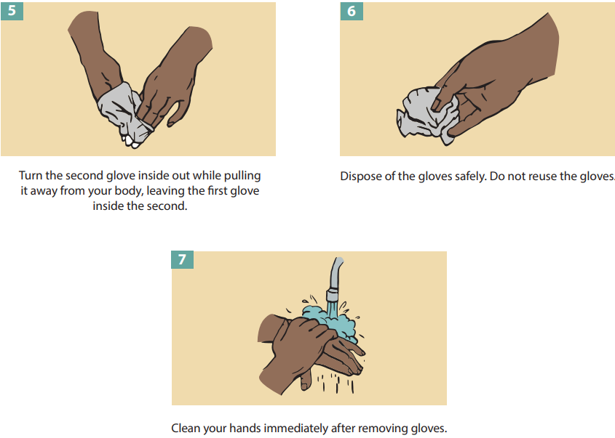

Sample Customer Safety Commitment

Copy the sample on the next page into a new document. Then customize it with your company name, logo, and letterhead.
< Company Logo & Letterhead Here >

Customer Safety Commitment

We hope that you and your family are healthy and safe. <Company name> is committed to providing our customers with exceptional service delivered safely by a highly qualified team.
We are working hard to follow New York State and CDC guidelines to keep your family and our employees as safe as possible.
Our employees are following these steps:
- All employees have completed company training on our COVID-safe work practice policy that incorporates guidance from CDC, NYS Department of Health, OSHA, and other experts.
- Health screening with a supervisor before work to ensure no fever, symptoms, or recent exposure.
- Washing hands or using approved hand sanitizer at appropriate times.
- Stocking our vehicles with personal protective equipment, cleaning supplies, and trash bags.
- Using protective equipment such as masks and gloves at all times.
- Practicing social distancing from you and your family.
- Disinfecting our equipment and vehicles between jobs to ensure that we’re as clean as possible upon arriving at your home.
- Disinfecting surfaces and items that we touch in your home.
- Collecting our trash in a responsible manner and taking it away for safe disposal.
We require that you follow these steps:
- Inform us if anyone in your household is sick or has been exposed to someone who has tested positive for COVID-19 in the past 14 days. We will be happy to re-schedule your work once it’s safe for you and our crew.
- You will not be present in rooms where we will perform work.
- You will exercise social distancing, including maintaining a minimum of six (6) feet from our workers at all times.
- Please wear a face covering when not separated from our crew by a closed door.
- Before we enter your home, make your home a safe working environment for our crew by disinfecting railings, door knobs, and other surfaces that we may touch.
- For their safety and ours, please keep pets and children out of the work area and our paths to the work area.
Thank you!
If you have any questions, concerns, or compliments, please contact
<owner / manager name>
<company contact info>

Sample Health Screening Questionnaire
- Name:
- Date:
  - A temperature equal to or greater than 100.0 degrees Fahrenheit; -
  - Currently experiencing ANY of the following symptoms:
    - Fever or chills,
    - Cough,
    - Shortness of breath or difficulty breathing,
    - Fatigue,
    - Muscle or body aches,
    - Headache,
    - New loss of taste or smell,
    - Sore throat,
    - Congestion or runny nose,
    - Nausea or vomiting,
    - Diarrhea
  - Any known close contact with a person confirmed or suspected to have COVID-19 in the past 14 days;
  - Tested positive for COVID-19 through a diagnostic test in the past 14 days

By clicking YES below, I certify that none of the above statements apply to me and I meet the eligibility criteria to enter the workplace. I understand that I must answer this accurately and completely, otherwise I will be held accountable and subject to disciplinary action if found untrue. The attestation is valid for only one day (the day it’s submitted).
Yes
No

Sources
- Advice for In-Home Contractors
  - https://www.health.ny.gov/publications/6730.pdf

- ASHRAE Brief: Pandemic COVID-19 and Airborne Transmission
  - https://www.ashrae.org/file%20library/technical%20resources/covid-19/eiband-airbornetransmission.pdf

- ASHRAE Epidemic Residential Guidance
  - https://www.ashrae.org/file%20library/technical%20resources/covid-19/ashrae-residential-c19-guidance.pdf

- Construction Guidelines for Employers and Employees
  - https://www.governor.ny.gov/sites/governor.ny.gov/files/atoms/files/ConstructionShortGuidelines.pdf

- COVID-19 and Air Filtration Frequently Asked Questions (FAQs)
  - https://www.nafahq.org/covid-19-corona-virus-and-air-filtration-frequently-asked-questions-faqs/#What%20you%20need%20to%20know%20about%20keeping%20you%20and%20your%20building%20safe

- COVID-19 Industry Guidance: Delivery Services
  - https://covid19.ca.gov/pdf/guidance-delivery-services.pdf

- Demonstration of Donning (Putting On) Personal Protective Equipment (PPE)
  - https://www.youtube.com/watch?v=of73FN086E8
- Demonstration of Doffing (Taking Off) Personal Protective Equipment (PPE)
  - https://www.youtube.com/watch?v=PQxOc13DxvQ
  - https://www.cdc.gov/vhf/ebola/pdf/poster-how-to-remove-gloves.pdf?fbclid=IwAR0i5PeHnaG7yjcO99Guf6jL2vgbUtsGJz2cna-3gR2NKLsYLzdUFOWnYcY

- Disinfecting Your Facility if Someone is Sick
https://www.cdc.gov/coronavirus/2019-ncov/community/disinfecting-building-facility.html

- Discontinuation of Isolation for Persons with COVID -19 Not in Healthcare Settings
  - https://www.cdc.gov/coronavirus/2019-ncov/hcp/disposition-in-home-patients.html

- General Respiratory Protection Guidance for Employers and Workers
  - https://www.osha.gov/dts/shib/respiratory_protection_bulletin_2011.html

- Guideline for Disinfection and Sterilization
  - https://www.cdc.gov/infectioncontrol/guidelines/disinfection/disinfection-methods/chemical.html

- How To Take Your Temperature
  - https://my.clevelandclinic.org/health/articles/9959-thermometers-how-to-take-your-temperature

- Interim Guidance for Cleaning and Disinfection of Public and Private Facilities for COVID-19
  - https://coronavirus.health.ny.gov/system/files/documents/2020/03/cleaning_guidance_general_building.pdf

- Interim Guidance on Handling Non-COVID-19 Public Health Activities that Require Face-to-Face Interaction with Clients in the Clinic and Field in the Current COVID-19 Pandemic
  - https://www.cdc.gov/coronavirus/2019-ncov/hcp/non-covid-19-client-interaction.html

- Interim Guidelines for Construction Activities During the COVID-19 Public Health Emergency
  - https://www.governor.ny.gov/sites/governor.ny.gov/files/atoms/files/ConstructionMasterGuidance.pdf

- OSHA COVID-19 Control & Prevention
  - https://www.osha.gov/SLTC/covid-19/standards.html and
https://www.osha.gov/SLTC/covid-19/controlprevention.html#repair_services and https://www.osha.gov/SLTC/covid-19/controlprevention.html#health and https://www.osha.gov/SLTC/covid-19/construction.html

- Recommended Guidance for Extended Use and Limited Reuse of N95 Filtering Facepiece Respirators
https://www.cdc.gov/niosh/topics/hcwcontrols/recommendedguidanceextuse.html

- Reopening: Guidance for At-Home Service Providers
  - https://aiha-assets.sfo2.digitaloceanspaces.com/AIHA/resources/Reopening-Guidance-for-At-Home-Service-Providers_GuidanceDocument.pdf
- Taking Employee Temperatures
  - https://www.shrm.org/ResourcesAndTools/tools-and-samples/exreq/Pages/Details.aspx?Erid=1559

- What to Do If You Are Sick
  - https://www.cdc.gov/coronavirus/2019-ncov/if-you-are-sick/index.html

- What You Should Know About COVID-19 and the ADA, the Rehabilitation Act, and Other EEO Laws
  - https://www.eeoc.gov/wysk/what-you-should-know-about-covid-19-and-ada-rehabilitation-act-and-other-eeo-laws

